GCFC Breast Cancer Shirt Order Form
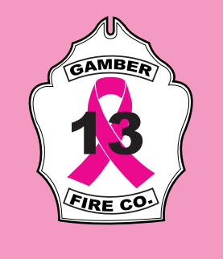

← Shirt Front
Price List
Gildan Hooded Pullovers | S – XL: $26.00  2X: $27.50  3X– 5X: $29.00
Gildan Long Sleeve Tee | S – XL: $17.75  2X: $19.75  3X – 5X: $20.25
Gildan Short Sleeve Tee | S – XL: $15.00  2X or 3X: $18.00
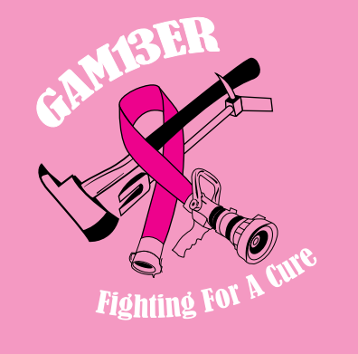

Shirt Back →

For each garment purchased, $5 is donated to a local charity.
Thank you for your donation!
Name | Quantity | Type of Shirt/ Sweatshirt | Size | Cost | Total

General Public: Make checks payable to Gamber and Community Fire Company.
Mail order form and payment to the address below, Attn: Quartermaster Committee.
All order forms and payment must be received by August 20, 2018.
3838 Niner Rd. Finksburg MD.21048
Or drop off at the station

